

Practices for Secure Software Report

Table of Contents
Document Revision History 3
Client 3
Instructions 3
Developer 4
1. Algorithm Cipher 4
2. Certificate Generation 4
3. Deploy Cipher 4
4. Secure Communications 4
5. Secondary Testing 4
6. Functional Testing 4
7. Summary 4
8. Industry Standard Best Practices 4

Document Revision History

Version | Date | Author | Comments
1.0 | 4/18/2026 | Ben Ezekiel | Initial release

Client



Instructions

Submit this completed practices for secure software report. Replace the bracketed text with the relevant information. You must document your process for writing secure communications and refactoring code that complies with software security testing protocols.

- Respond to the steps outlined below and include your findings.
- Respond using your own words. You may also choose to include images or supporting materials. If you include them, make certain to insert them in all the relevant locations in the document.
- Refer to the Project Two Guidelines and Rubric for more detailed instructions about each section of the template.

Developer
Ben Ezekiel

Algorithm Cipher

I implemented SHA-256 as the checksum algorithm for the /hash endpoint. SHA-256 is part of the SHA-2 family and produces a 256-bit fixed-length digest from variable-length input. It is widely used for integrity checking because even a small change in the input produces a completely different hash output, which makes tampering easy to detect.
This implementation uses the Java MessageDigest API and UTF-8 input encoding. The endpoint also generates a random nonce with SecureRandom so that each sample data string is unique during demonstration. SHA-256 is a one-way hash rather than a symmetric or asymmetric cipher, so it does not use encryption keys to recover the original message. Instead, it is appropriate for checksum verification and integrity validation. In the broader history of encryption, older algorithms such as MD5 and SHA-1 are no longer recommended for security-sensitive integrity checks because of known collision weaknesses, while SHA-256 remains a standard, modern choice for this type of assignment.

Certificate Generation
Insert a screenshot below of the CER file.

Deploy Cipher
Insert a screenshot below of the checksum verification.

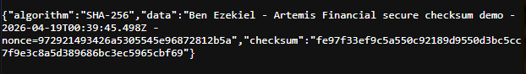

Secure Communications
Insert a screenshot below of the web browser that shows a secure webpage.

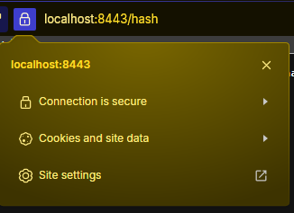

Secondary Testing
Insert screenshots below of the refactored code executed without errors and the dependency-check report.

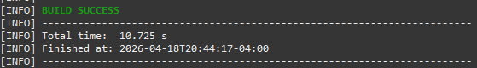
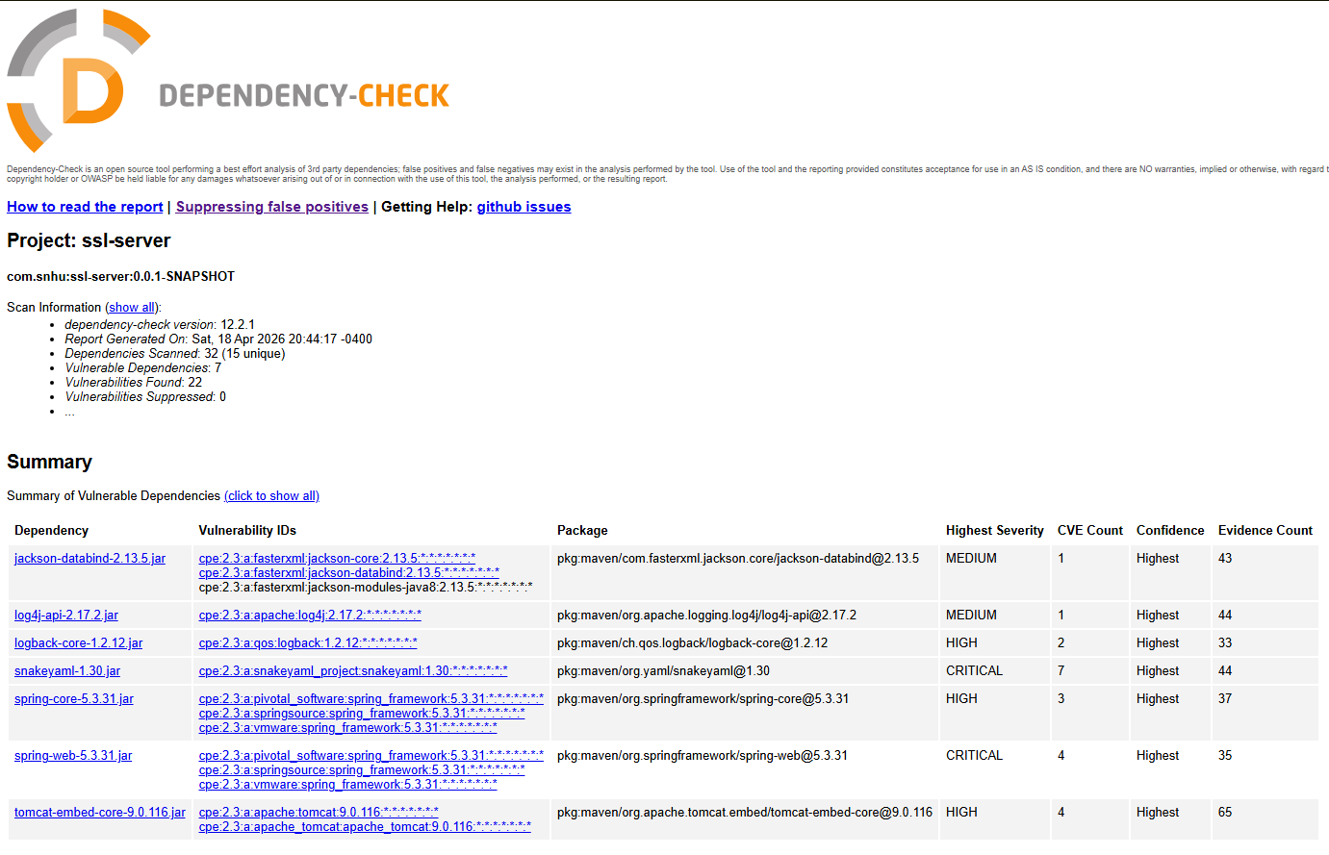

Functional Testing
Insert a screenshot below of the refactored code executed without errors.

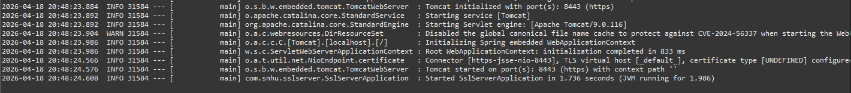
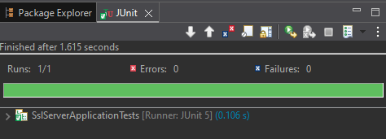

Summary

This refactor improves several areas from the vulnerability assessment process flow. It addresses software component security by upgrading outdated third-party libraries, transport security by enforcing HTTPS with a certificate-backed keystore, and application-layer security by reducing the attack surface and adding secure headers. It also improves integrity controls through SHA-256 checksum generation.
My process for adding layers of security was to start with the dependency-check output, identify which findings were tied to obsolete framework versions, and then refactor the project in a way that reduced both known vulnerabilities and unnecessary functionality. That approach produced stronger defense in depth than simply adding a checksum route alone.

Industry Standard Best Practices

I applied several industry standard secure-coding practices in this refactor. First, I upgraded outdated dependencies instead of leaving the project on a known-vulnerable baseline. Second, I removed an unused dependency to reduce the overall attack surface. Third, I used HTTPS, a certificate keystore, secure response headers, and conservative error settings so the application shares less unnecessary information with clients. Fourth, I used SecureRandom for nonce generation and SHA-256 for integrity verification instead of legacy hash algorithms.

